Subject Line: Brands & Benefits You Can Bank On!

Dear First Name,

The State Bankers Association is pleased to be able to partner with industry-leading suppliers to provide our members with discounts on the products your bank uses every day.

When you use an SBA program it not only benefits your bottom line – it also supports our primary mission: advocacy on behalf of State’s banks.

As part of your SBA membership, your bank can access our unique program with Office Depot where you’ll receive exclusive discounts on Office Depot brands designed to meet or beat national brands in quality and value.

 | 


Our brands maximize efficiency and cost-effectiveness in every category with TUL® writing instruments, Ativa® technology and Highmark® cleaning and breakroom supplies, plus furniture from Realspace® and WorkPro®. What’s more, as a member of a state bankers association, you receive exclusive discounts and benefits, including:

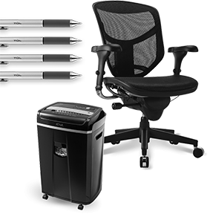 | • UP TO 80% OFF regular prices on a core  • list of 840+ frequently ordered products  • COMPETITIVE DISCOUNTS on your own  • customized list of 75 items  • UP TO 10% OFF the everyday, regular  • prices at officedepot.com on select  • products in our full-line catalog  • EMPLOYEE DISCOUNT program  • FAST & FREE DELIVERY on qualifying  • orders of $50 or more within our local  • delivery areas (See below for details.)


 |  | 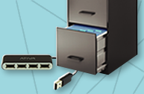
  Register for your Office Depot® account at
  business.officedepot.com/banksignup
  or place your order today at business.officedepot.com

Office Depot is a trademark of The Office Club, Inc. © 2016 Office Depot, Inc. All rights reserved.
Fast & Free Delivery: Orders outside our local delivery area and most furniture, oversized and special order items do not qualify. Non-qualifying orders incur a delivery charge (minimum charge of $7.95). Many orders can be delivered next business day (between 8:30 AM and 5:00 PM) if placed online or via phone by 5:00 PM or via fax by 3:00 PM, local time (In most locations). Other restrictions apply. See business.officedepot.com, call 888.2.OFFICE or ask your Account Manager for details.
Valid at business.officedepot.com or by phone at 888.2.OFFICE and fax at 888.813.7272 only. Offers are non-transferable. Office Depot reserves the right to limit quantities sold to each customer. We are not responsible for errors.

