Subject Line: Bank on Us for Your Copy & Print Services

Dear First Name,

The State Bankers Association is pleased to be able to partner with industry-leading suppliers to provide our members with discounts on the products your bank uses every day.

When you use an SBA program it not only benefits your bottom line – it also supports our primary mission: advocacy on behalf of State’s banks.

As part of your SBA membership, your bank can access our unique program with Office Depot where you’ll receive exclusive discounts on a wide selection of copy and print services.

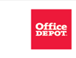

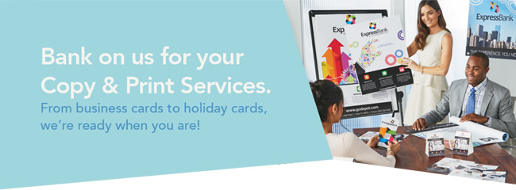
Let Office Depot® copy, print and manage your documents to save you time and money. From business cards and letterhead to marketing and advertising tools, our Print Services will convey your message while adding visibility to your brand. | 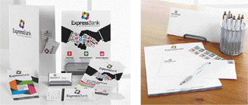

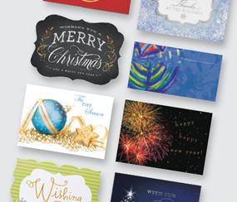 | It’s the season to customize your holiday greetings to friends, family, colleagues and clients. Personalized cards can enhance your business relationships and express your heartfelt sentiments to those near and dear. We have a wide selection of designs that will brighten anyone’s holidays!

Register for your Office Depot® account today at
business.officedepot.com/banksignup

Office Depot is a trademark of The Office Club, Inc. OfficeMax is a trademark of OMX, Inc. © 2016 Office Depot, Inc. All rights reserved.

