
Turn to Workspace Interiors by Office Depot® for Your Bank’s Next Furnishing Project
Workspace Interiors by Office Depot® is a full-service office furniture dealership that can meet all your bank’s needs. Whether you’re looking for a partner to manage the entire process of your next project or one that can support your architecture and design firm, count on Workspace Interiors.
Everything You Need to Realize Your Ideas — All in One Place
Our professional team and network of 200+ manufacturers enable us to provide service on all of the logistical aspects of furnishing your design — so you can stay focused on your business. You supply the vision. We’ll make it reality.

We’re Invested in the Outcome of Your Project, Big or Small
Our nationwide reach provides better buying power, scalable services and flexible offerings. That means you’ll find a wider range of improved options to fit within your budget.
- North American in scope with a single operating platform
- Nationwide reach for consistent support across the country
- Single point of contact for seamless service and one set of standards
- Scalable support and resources
Workspace Interiors by Office Depot draws on a range of turnkey planning and installation services to provide assistance at every project stage.

Whether your project is well-defined or not defined at all, we have the resources and knowledge to help you every step of the way.

Creative Services
- Space planning
- Specifications
- 3D views and renderings
- Finish specifications
- Installation drawings

Project Management
- Establishment of project parameters
- Project administration
- Ongoing support

Labor Services
- Delivery
- Installation and reconfiguration
- Warehousing
- Move management
- Disposition and redeployment of assets

Financial Services
- Leasing
- Renting
- Financing
- Used furniture brokerage

Other Services
- Standards programs
- Sustainability/LEED
- E-commerce

With more than 250 dedicated furniture consultants, Workspace Interiors by Office Depot® puts efficiency, cost savings and control at your service — so you have space to work and room to grow.

CASE STUDY: CLACKAMAS COUNTY BANK
Comfort meets community in an environment fueled by innovation
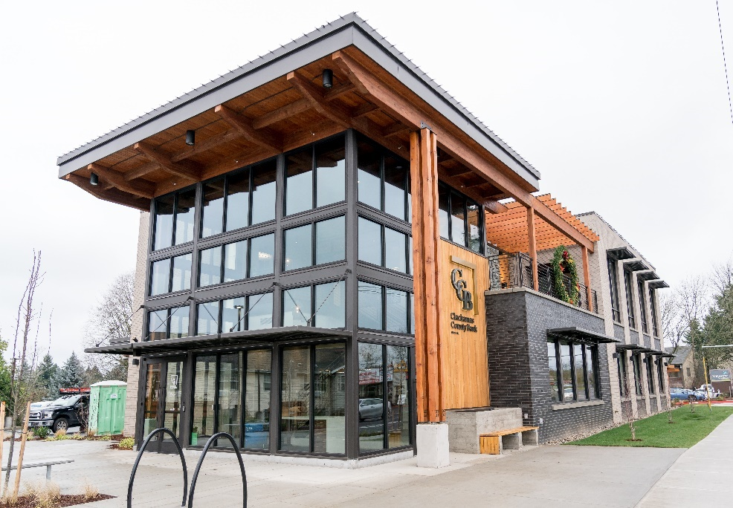
Founded in 1911, Clackamas County Bank is the oldest community bank in Oregon. Evolving from hitching posts and water troughs to interactive transaction machines, the bank has a storied family history that includes surviving the Great Depression and being home to the first female bank president in Oregon. But throughout the years, the Bank’s Gresham branch outgrew its location, which was also rented.
The bank leveraged the Association’s Office Depot program to receive additional discounting for this project. In December 2018, ground was broken for the new 8,400-square-foot two-story office with multiple amenities, and Workspace Interiors was there from the beginning.
RENDERING RESULTS, FROM START TO FINISH
Because Clackamas County Bank hadn’t built a new facility in decades, having a consultative approach was essential. Workspace Interiors presented a variety of “good,” “better” and “best” design options to the bank’s stakeholders. The entire project was rendered in 3D color images of the actual furniture and finishes to help members of the project team clearly visualize the results so that they could make informed and unanimous selections during each step of the project.
These options were then provided to the bank’s interior design firm. Workspace Interiors also provided specifications and handled all installation of the furniture.
OPTIMIZING ENVIRONMENTS AND MAXIMIZING VALUE
Presentations and ongoing interface from Workspace Interiors reassured everyone involved of the value that Workspace Interiors provided. Thanks to the partnership, Clackamas County Bank was able to leverage a reserved manufacturing and shipping schedule. Workspace Interiors received the bank’s products and stored them locally to meet the bank’s opening date. During that time, weekly meetings were held in-person in Oregon, along with videoconferencing and phone meetings so that the bank could select components and elements that would help bring its new location to life.
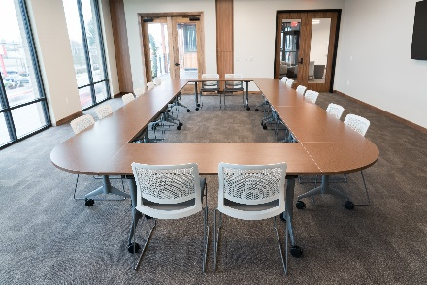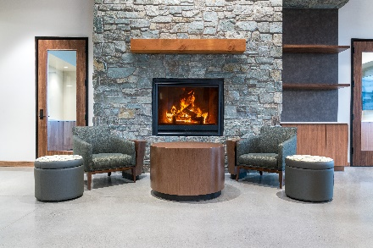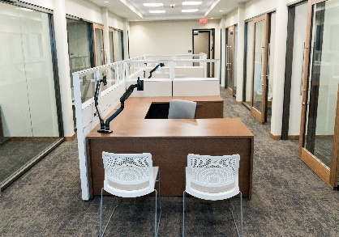
From design to build, every component of the project shared a singular focus: be inviting to the community and customers of Clackamas County Bank. With the addition of a large community room that includes amenities such as a full kitchen and outdoor deck with fireplace — as well as private conference rooms — the bank is now able to extend invitations to local nonprofits as well as to their customers to reserve and use these spaces.
Partner with Workspace Interiors to gain extensive expertise in existing trends, proven solutions and innovative products, so you can get the most out of your workplace — from concept to completion.
To learn more, call 877-543-0944, email info@officedepot.com or visit WorkspaceInteriorsOD.com.

